Installing and using Skype (please ensure you check your camera and speakers are working – you can test this via tools)

Google ‘download skype’ and find the following page to access a download. (Your computer may run on a different setting than shown here so please ensure you can download this before continuing).

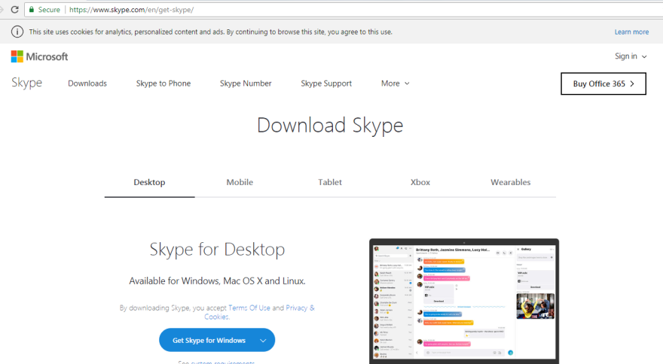

Click on skype for windows – this will open a window showing it is being downloaded. Follow the prompts to ‘run’ this on your machine until it is downloaded and asks you to open. You will have questions where you will need to enter details such as your email address, skype name and details.

To search for the person you want to skype, type in skype name eg: janet.arthur98 in the top left hand side shown above. The following picture should indicate where you need to be in order to contact the person.

Click on the name displayed on left hand side. This will then allow you to then call the person using the icons at top right of picture. You will need to click on the video icon top right in order to be seen.

